7.1.35 Editors - 3D View - Header - Armature - Pose mode - Pose menu
Detailed Table of content 1
Pose Mode - Pose Menu 5
Clear Transform 5
Clear Transform 5
Apply 6
Apply Pose as Rest Pose 6
Apply Selected as Rest Pose 6
Apply Visual Transform to Pose 6
Assign Custom Property Values as Default 6
Snap 7
Last Operator Snap 7
Animation 7
In-Betweens 8
Header values 8
Push Pose from Rest Pose 8
Relax Pose to Rest Pose 9
Push Pose from Breakdown 9
Relax Pose to Breakdown 10
Propagate 11
Last Operator Propagate Pose 11
Single Operators 12
Copy 12
Paste 12
Paste Flipped 12
Pose Library 13
Motion Paths 14
Bone Groups 15
Parent 16
Inverse Kinematics 16
Constraints 17
AutoName Left/Right 18
AutoName Front/Back 18
AutoName Top/Bottom 19
Flip Names 19
Flip Quats 19
Change Armature Layers 19
Change Bone Layers 20
Show/Hide 20
Bone Settings 20

Detailed Table of content

Detailed table of content
Detailed Table of content 1
Pose Mode - Pose Menu 5
Clear Transform 5
Clear Transform 5
All 5
Clear User Transforms 5
Location 5
Rotation 6
Scale 6
Reset Unkeyed 6
Last Operator Clear User Transforms 6
Only Selected 6
Apply 6
Apply Pose as Rest Pose 6
Apply Selected as Rest Pose 6
Last Operator Apply Pose as Rest Pose 6
Selected only 6
Apply Visual Transform to Pose 6
Assign Custom Property Values as Default 6
Last Operator Assign Custom Property Values as Default 7
Process data properties 7
Process bone properties 7
Snap 7
Last Operator Snap 7
Offset 7
Animation 7
Insert Keyframe 7
Delete Keyframes 7
Clear Keyframes 7
Change Keying Set 7
In-Betweens 8
In Between 8
Header values 8
Push Pose from Rest Pose 8
Last Operator Push Pose from Rest Pose 8
Percentage 8
Previous Keyframe 8
Next Keyframe 8
Channels 8
Axis Lock 8
Relax Pose to Rest Pose 9
Last Operator Relax Pose to Rest Pose 9
Percentage 9
Previous Keyframe 9
Next Keyframe 9
Channels 9
Axis Lock 9
Push Pose from Breakdown 9
Last Operator Push Pose 9
Percentage 9
Previous Keyframe 9
Next Keyframe 9
Channels 9
Axis Lock 10
Relax Pose to Breakdown 10
Last Operator Relax Pose to Breakdown 10
Percentage 10
Previous Keyframe 10
Next Keyframe 10
Channels 10
Axis Lock 10
Breakdowner 10
Last Operator Pose Breakdowner 10
Percentage 10
Previous Keyframe 10
Next Keyframe 11
Channels 11
Axis Lock 11
Propagate 11
Last Operator Propagate Pose 11
Terminate Mode 11
While Held 12
To Next Keyframe 12
To Last Keyframe 12
Before Frame 12
Before Last Keyframe 12
On Selected Keyframes 12
On Selected Markers 12
End Frame 12
Single Operators 12
Copy 12
Paste 12
Paste Flipped 12
Last Operator Paste Pose 12
Flipped on X Axis 12
On Selected Only 13
Pose Library 13
Browse Poses 13
Last Operator Pose lib Browse Poses 13
Pose 13
Add Pose 13
Add New 13
Add New (Current Frame) 13
Replace Existing 13
Last Operator Pose Lib Add Pose 13
Frame 13
Pose Name 14
Rename Pose 14
Last Operator Pose Lib Rename Pose 14
New Pose Name 14
Pose 14
Remove Pose 14
Last Operator Pose Lib Remove Pose 14
Pose 14
Motion Paths 14
Calculate 14
Last Operator Calculate Object Path 15
Start 15
End 15
Bake Location 15
Clear 15
Bone Groups 15
Assign to New Group 15
Assign to Group 15
Last operator Add Selected to Bone Group 15
Bone Group Index 15
Remove selected from Bone Groups 16
Remove Bone Group 16
Parent 16
Inverse Kinematics 16
Add IK to Bone 16
Last Operator Add IK to Bone 17
With Targets 17
Remove IK 17
Constraints 17
Add (With Targets) 17
Copy Constraints to selected Bones 18
Clear Pose Constraints 18
AutoName Left/Right 18
AutoName Front/Back 18
AutoName Top/Bottom 19
Flip Names 19
Flip Quats 19
Change Armature Layers 19
Last Operator Change Armature Layers 20
Layer 20
Change Bone Layers 20
Last Operator Change Bone Layers 20
Layer 20
Show/Hide 20
Show Hidden 20
Hide Selected 20
Hide Unselected 20
Bone Settings 20
Last Operator Collection Boolean Set 20

Pose Mode - Pose Menu

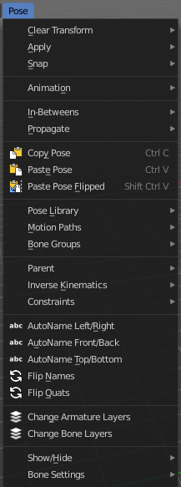
The Pose menu contains the tools to work with Armature objects in Pose mode. This means here you find all the tools that you need to pose and animate your armature.

Clear Transform

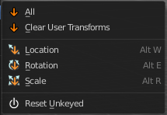
Clear Transform
Clear transform is a menu with some Clear functionality. You need to have the bones selected where you want to perform the operation. Unselected bones will not be calculated.

All
Resets location, rotation and scale back to the Rest pose.

Clear User Transforms
Resets Pose of selected bones back to keyframe state.

Location
Resets location back to the Rest pose.

Rotation
Resets rotation back to the Rest pose.

Scale
Resets scale back to the Rest pose.

Reset Unkeyed
Resets the pose for the selected bones back to the state of the latest keyframe.

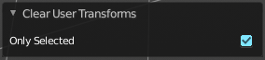
Last Operator Clear User Transforms

Only Selected
Clear User transform for selected armature part, or for the whole armature.

Apply
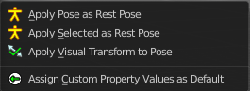
Apply is a menu with some Apply functionality.

Apply Pose as Rest Pose
You need a rest pose where you can reset the pose back to. With this tool you can set the current pose to be the new Rest pose.

Apply Selected as Rest Pose
You need a rest pose where you can reset the pose back to. With this tool you can set the current pose of the selected bones to be the new Rest pose.

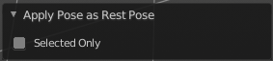
Last Operator Apply Pose as Rest Pose

Selected only
Just apply the pose to the selected part.

Apply Visual Transform to Pose
Apply final constrained position of posed bones to their transform.

Assign Custom Property Values as Default
Assigns the current values of custom properties as their defaults. This allows to use them as part of the rest pose state in nLA track mixing.

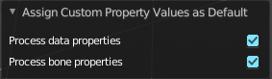
Last Operator Assign Custom Property Values as Default

Process data properties
Include the process data properties.

Process bone properties
Include the process bone properties.

Snap

Here you can choose several methods to snap one element to another. The menu items should be self explaining.

Last Operator Snap

Some snap operations shows a last operation panel, some not.

Offset
If the selection should snap as a whole, or if each individual element of the selection should snap.

Animation
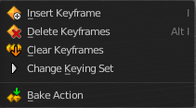
Animation is a sub menu around animation functionality. You need to have an object in the scene.

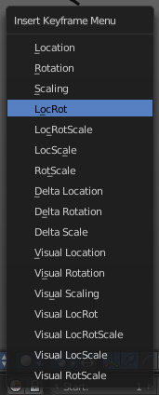
Insert Keyframe
Opens a menu where you can insert a keyframe with a defined keying set.

Delete Keyframes
Deletes keyframes at the current frame.

Clear Keyframes
Deletes all keyframes.

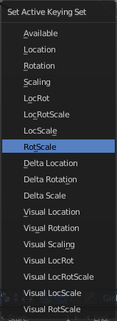
Change Keying Set
Opens a menu where you can change the keying set.

In-Betweens

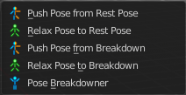
In Between
In Between are tools to influence the look of the pose between the keyframes.
For example, record a keyframe at frame 1, then record a keyframe at frame 20. Then go to frame 10, and activate one of the tools. Now you can play around with the settings. And when you are satisfied with the result then you can record a keyframe at this position.

Header values
When you activate one of the tools, then you will see a percentage value in the header. And some hotkeys. The hotkeys W, E and R stands for the usual transform modes move, rotate or scale. Hotkey B stands for Bendy Bones. And C is for a custom property. This hotkeys are hard coded, and cannot be changed in the input manager.

Push Pose from Rest Pose
Exxagerrates the current pose. Pushes the current pose further away from the rest pose.

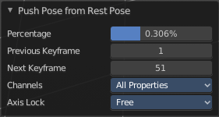
Last Operator Push Pose from Rest Pose

Percentage
The percentage of exxageration.

Previous Keyframe
The keyframe position before the current frame.

Next Keyframe
The keyframe position after the current frame.

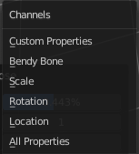
Channels
Here you can limit the push effect to specific channels.

Axis Lock
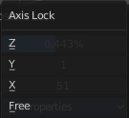
Here you can limit the push effect to specific axis.

Relax Pose to Rest Pose
Relaxes the current pose towards the Rest pose.

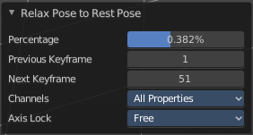
Last Operator Relax Pose to Rest Pose

Percentage
The percentage of relaxing.

Previous Keyframe
The keyframe position before the current frame.

Next Keyframe
The keyframe position after the current frame.

Channels
Here you can limit the relax effect to specific channels.

Axis Lock
Here you can limit the relax effect to specific axis.

Push Pose from Breakdown
Exxagerrates the current pose. Pushes the current pose further away from the previous pose.

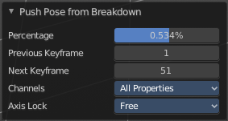
Last Operator Push Pose

Percentage
The percentage of exxageration.

Previous Keyframe
The keyframe position before the current frame.

Next Keyframe
The keyframe position after the current frame.

Channels
Here you can limit the push effect to specific channels.

Axis Lock
Here you can limit the push effect to specific axis.

Relax Pose to Breakdown
Relaxes the current pose.

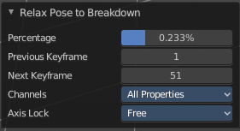
Last Operator Relax Pose to Breakdown

Percentage
The percentage of relaxing.

Previous Keyframe
The keyframe position before the current frame.

Next Keyframe
The keyframe position after the current frame.

Channels
Here you can limit the relax effect to specific channels.

Axis Lock
Here you can limit the relax effect to specific axis.

Breakdowner
Creates a suitable breakdowner pose on the current frame.

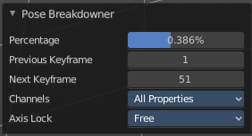
Last Operator Pose Breakdowner

Percentage
The percentage of exxageration.

Previous Keyframe
The keyframe position before the current frame.

Next Keyframe
The keyframe position after the current frame.

Channels
Here you can limit the breakdowner pose to specific channels.

Axis Lock
Here you can limit the breakdowner pose to specific axis.

Propagate

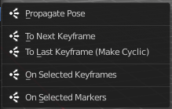
The Propagate tool automates the process of copying and pasting between keyframes. It copies the pose of the selected bones on the current frame over to the keyframes by the chosen Termination mode in the Last Operator Propagate Pose.
The different Propagate methods can be adjustetd in the Last operator too. Here you will find even more methods. The menu just lists the common ones.
The methods are quite self explaining, but are explained in the last operator section.

Usage example with Termination mode "On Selected Keyframes".
Create a little armature.
Set a keyframe at frame 0.
Set a keyframe at frame 20.
Pose frame 20.
Set a keyframe at frame 40. It will most probably be identical with Frame 20.
Now select those Keyframes at position 40 in the Dope Sheet Editor.
Set position to Frame 0.
Press Propagate, and in the Last operator Propagate Pose choose On Selected Keyframes.
The selected keyframes at frame 40 will now turn into the corresponding keyframes from position 0.

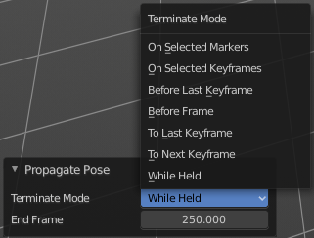
Last Operator Propagate Pose

Terminate Mode
A dropdown box where you can choose between different termination modes for Propagate.

While Held
While held it tries to guess when to stop propagating by examining the pauses in the animation curves per control (This means all F-Curves for a bone instead of per F-Curve).

To Next Keyframe
Copies the pose to the first keyframe after the current frame.

To Last Keyframe
Replaces the last keyframe.

Before Frame
Copies to all keyframes between current frame and the End frame option.

Before Last Keyframe
To all keyframes from current frame until no more are found.

On Selected Keyframes
Applies the pose of the selected bones to all selected keyframes.

On Selected Markers
Copies to all keyframes on frames with Scene Markers after the current frame.

End Frame
Defines the end frame for the Propagate.

Single Operators

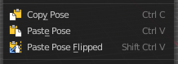
Copy
Copies the current pose. You copy what you have selected.

Paste
Pastes a previous copied pose.

Paste Flipped
Pastes a previous copied pose, but flipped along X axis.

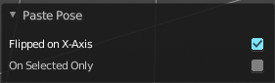
Last Operator Paste Pose

Flipped on X Axis
Paste the pose flipped along X Axis.

On Selected Only
Paste just on the selected bones. Not on the unselected.

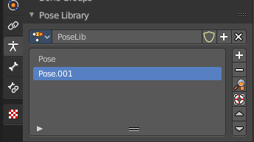
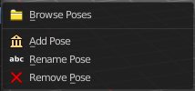
Pose Library
The content of this menu belongs to the Pose library. Which can be found in the Properties editor.

Browse Poses
With this feature you can browse through the available poses in the 3D view. While operation you will see informations in the header. It shows you what the current pose is, and how to navigate to the next or previous pose.
Note that you need to have the bones selected for which you want to display the poses. When in doubt, select all bones.

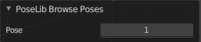
Last Operator Pose lib Browse Poses

Pose
Here you can scroll through the poses.

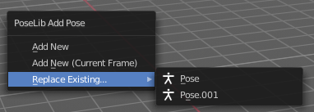
Add Pose
Here you can add a new pose for your armature to the pose library.
Note that you need to have the bones selected for which you want to add the pose. It just records the pose for the selected bones.
Calling the tool opens a popup where you can choose how you want to add the current pose.

Add New
Adds a new pose.

Add New (Current Frame)
Adds a new pose at the current frame. It does NOT record a keyframe.

Replace Existing
Here you can replace an existing pose.

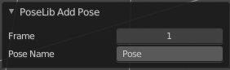
Last Operator Pose Lib Add Pose

Frame
The frame at which this pose should be created

Pose Name
Here you can rename the pose while creation.

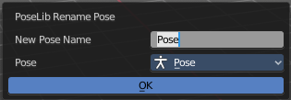
Rename Pose
Here you can rename a pose. It opens a popup menu where you can choose the pose to rename, and where you can rename it. One pose at a time.

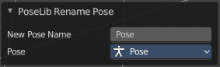
Last Operator Pose Lib Rename Pose

New Pose Name
Here you can enter the new pose name.

Pose
Here you can choose the pose that you want to rename.

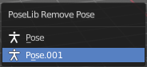
Remove Pose
Removes the currently active pose. The tool opens a popup where you can choose the pose to remove.

Last Operator Pose Lib Remove Pose

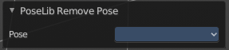
Pose
Here you can again choose which pose to remove.
Attention! This dialog is bugged. When you have two animations in the library and remove one, then the box shows empty. When you now switch to the other pose here, then you remove both poses. There is no way back, since you can't select the previous pose anymore.

Motion Paths
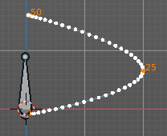
Objects can be animated. Let's say you send them from a to b to c. The object will move to b, then to c. Some kind of a path. This path is not visible by default.
With motion paths you can calculate this path, and make it visible.

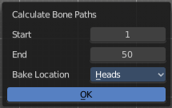
Calculate
Calculates the motion path of the selected object. It opens a panel where you can define the start and end frame of the calculation.

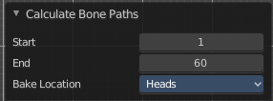
Last Operator Calculate Object Path

Start
Defines the start frame of the calculation.

End
Defines the end frame of the calculation.

Bake Location
Where to draw the curve. At the head or at the tail of the bone(s)

Clear
Clear remove the motion path from the object.

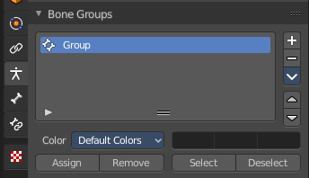
Bone Groups
Bone Groups is a menu to handle bone group functionality from within a menu in the 3D view. The bone groups themselves can be found in the Properties editor.

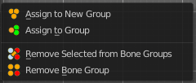

Assign to New Group
Assigns the selected bone(s) to a new group.

Assign to Group
Assigns the selected bone(s) to a existing group.

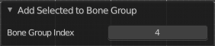
Last operator Add Selected to Bone Group
This last operator belongs to both tools. Assign to New Group, and Assign to Group.

Bone Group Index
Here you can adjust the Bone Group Index. An Index of 0 creates a new bone group. Higher values tries to assign the bone to existing bone groups instead.

Remove selected from Bone Groups
Removes the selected bone(s) from the assigned bone groups.

Remove Bone Group
Removes the currently active bone group.

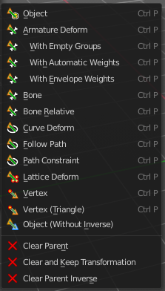
Parent
Parenting the skin or other armatures happens in Object mode. You can also parent in Pose Mode. It just does not make much sense since you need to enter Object mode for one of the objects anyways. The only somehow relevant settings in the parenting menu here is clear parent. But even this is better done in Object Mode.
The parenting menu is already explained in the Object menu in Object mode. So we won't repeat the whole description here.

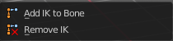
Inverse Kinematics
Inverse Kinematics is a menu with two isolated items from the whole bone constraints menu. The Inverse Kinematics. You could also add an Inverse Kinematics bone constraint by the Constraints / Add (With Targets) menu item from above. It is in the list. But this menu allows quick access without big search.

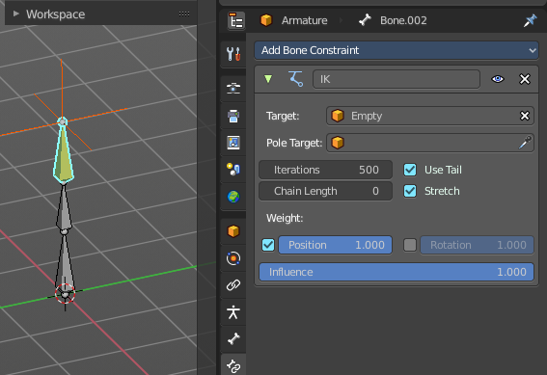
Add IK to Bone
Add IK to bone adds an IK bone constraint to the selected bone. When you add an IK constraints with just the bone selected, then it adds an empty as a handler too, and fills it in as a target.
Add IK calls a popup. When you have just one bone selected then you can choose between adding an empty as the target or to create the bone constraint without target.
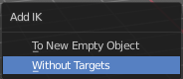
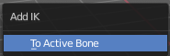
When you have more than one bone selected then you can just add the constraint to the active bone.

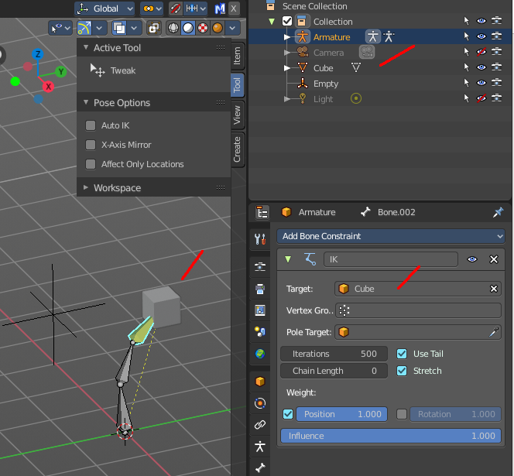
You can define a own target object too. The armature needs to be in pose mode. Let's create a cube or another primitive. Select it. Now hold down Shift, and click at the bone where you want to add the constraint too. Then choose Add (with Targets), and choose your constraint method. The cube will now be chosen as the target object.

Last Operator Add IK to Bone

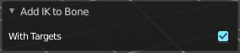
With Targets
Here you can define if you want to add the IK constraints with or without a target.

Remove IK
Removes all IK bone constraint(s) at the selected bone(s).

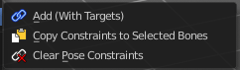
Constraints
Constraints is a menu that contains some tools around constraints.

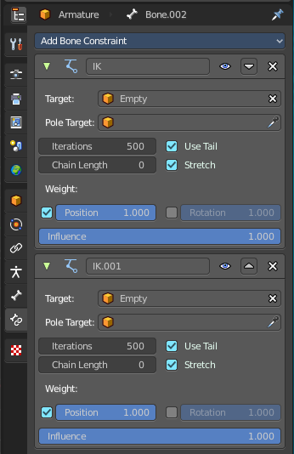
Add (With Targets)
Add (With Targets) calls the Constraints menu where you can choose the constraint that you want to add. When you add an IK constraints with just the bone selected, then it adds an empty as a handler too, and fills it in as a target. Which is similar to what you can do with the Add IK to Bone from the IK menu.

But you can add more than just the IK constraint. It is the same menu that you can open by clicking at the Add Bone Constraint dropdown menu in the Properties editor.

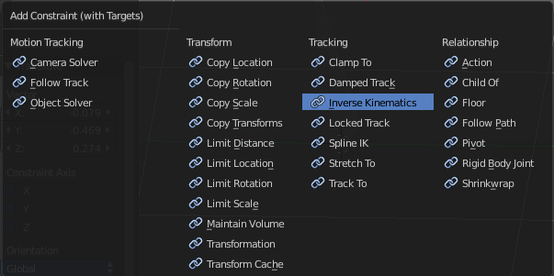

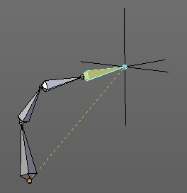

You can define a own target object too. The armature needs to be in pose mode. Let's create a cube or another primitive. Select it. Now hold down Shift, and click at the bone where you want to add the constraint too. Then choose Add (with Targets), and choose your constraint method. The cube will now be chosen as the target object.

Copy Constraints to selected Bones
Copies the constraints with all its settings to the selected bone.
Usage:
Select the bone where you want to copy the constraints to. Hold down shift, then select the bone that contains the constraints. Then perform the tool. The constraints will be copied.

Clear Pose Constraints
Removes all bone constraints modifiers from the bone.

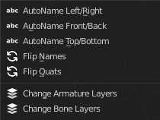
AutoName Left/Right
This tool automatically adds a suffix to all selected bones, based on their local position relative to the armature center.
Bones with a positive X Coordinate will receive a .L suffix. Bones with a negative X coordinate will receive a .R suffix.

AutoName Front/Back
This tool automatically adds a suffix to all selected bones, based on their local position relative to the armature center.
Bones with a positive Y Coordinate will receive a .Fr suffix. Bones with a negative Y coordinate will receive a .Bk suffix.

AutoName Top/Bottom
This tool automatically adds a suffix to all selected bones, based on their local position relative to the armature center.
Bones with a positive Z Coordinate will receive a .Top suffix. Bones with a negative Z coordinate will receive a .Bot suffix.

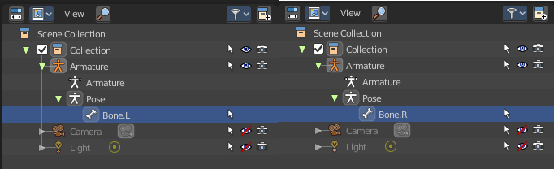
Flip Names
This tool requires to follow some name conventions. If there is a lower or upper case “L”, “R”, “left” or “right” with a separating dot in the bone name, then this tool renames the names of the selected bones to its counterpart. Bone.L becomes Bone.R.
This tool is useful when you mirror parts of the armature, and don't want to rename all the bones one by one.

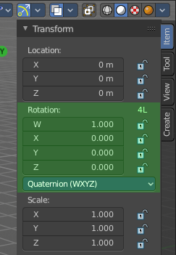
Flip Quats
This feature flips the quaternion rotation values of the currently selected bone(s). Positive values becomes negative, and negative values becomes positive.

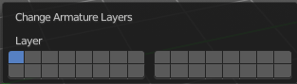
Change Armature Layers
Armature and bones has its own layer system. This menu item opens a popup where you can put the whole armature onto another layer.

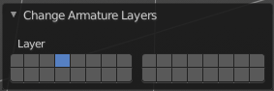
Last Operator Change Armature Layers

Layer
Here you can again put the armature onto another layer.

Change Bone Layers
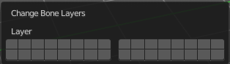
Armature and bones has its own layer system. This menu item opens a popup where you can put single selected bone(s) onto another layer.

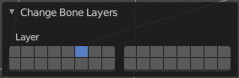
Last Operator Change Bone Layers

Layer
Here you can again put the selected bones onto another layer.

Show/Hide
Here you can show or hide the selected geometry

Show Hidden
Makes all hidden geometry visible again.

Hide Selected
Hides the selected geometry.

Hide Unselected
Hides the not selected geometry. The selected geometry stays visible.

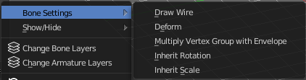
Bone Settings
Bone Settings is a menu with menu items to toggle special checkboxes in the Properties editor. But here you can do it for a selection too, and not just one object.

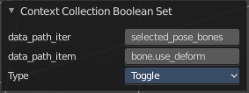
Last Operator Collection Boolean Set
Each of the menu items uses the same Last Operator. With different strings for the booleans.

